Indonesia Urges Food Security Cooperation between ASEAN and Canada

Jakarta, 13 July 2023. Minister of Foreign Affairs Retno Marsudi has urged for ASEAN and Canada to strengthen cooperation in the field of food security. Retno made the statement during the ASEAN - Canada Post Ministerial Conference (PMC) meeting on Thursday (13/7) in Jakarta.

Retno said that ASEAN-Canada relations will soon be elevated to the level of Strategic Partnership. The partnership must contribute to peace, stability, and the transformation of the region into an Epicentrum of Growth.

To achieve these goals, two areas of cooperation must be strengthened.

First, in the food security sector. Foreign Minister Retno said that currently the world is facing food insecurity. In addition, ASEAN countries face the threat of El Niño. This condition can have an impact on food crop harvests and cause disruptions in the global food supply chain.

In this regard, Canada is expected to increase trade cooperation in agricultural and food products with ASEAN. In addition, ASEAN - Canada can also collaborate in the field of agricultural technology, one of which is through Scholarship and Educational Exchange Development (SEED). Indonesia hopes that the joint commitment to strengthen regional preparedness in the field of food security can be reflected in a joint statement during the ASEAN-Canada Summit.

“As a global food powerhouse, Canada can play a crucial role, as a reliable partner for ASEAN’s food security by substantiating trade on quality agricultural and agrifood commodities,” Retno explained.

Second, cooperation to increase the participation of women and business groups for regional peace and development. Retno said that the ASEAN Outlook on the Indo-Pacific (AOIP) provides room for business and women to participate in regional peace and development, particularly through the implementation of the Plan of Action on Women, Peace, and Security and the Empowering Women for Sustainable Peace project.

Retno also invited Canada to participate in the ASEAN Indo-Pacific Forum: Implementation of the AOIP (AIPF).

"We also invite Canada to take part in the ASEAN Indo-Pacific Forum, a public-private dialogue forum to produce concrete cooperation," Retno said.

In addition, the meeting also discussed strengthening economic cooperation, including through the conclusion of the ASEAN - Canada Free Trade Agreement. ASEAN also encourages cooperation in strengthening human resources through the provision of scholarships. Other areas of cooperation raised were regional connectivity, digital economy, green economy, smart city, and maritime security.
The ASEAN Foreign Ministers also appreciated Canada's support for ASEAN's centrality and leadership in the region. Meanwhile, the Canadian Minister of Foreign Affairs said that Canada wishes to be a reliable partner for ASEAN. To that end, Canada has set aside USD 2 billion to fund various projects in ASEAN.

The meeting approved the Draft Joint Statement on ASEAN-Canada Strategic Partnership to be endorsed at the ASEAN-Canada Summit next September to formalise the ASEAN-Canada strategic partnership.

***

For further information, please contact the following:

Director for Information and Media of the Ministry of Foreign Affairs - Hartyo Harkomoyo (+62811831899)

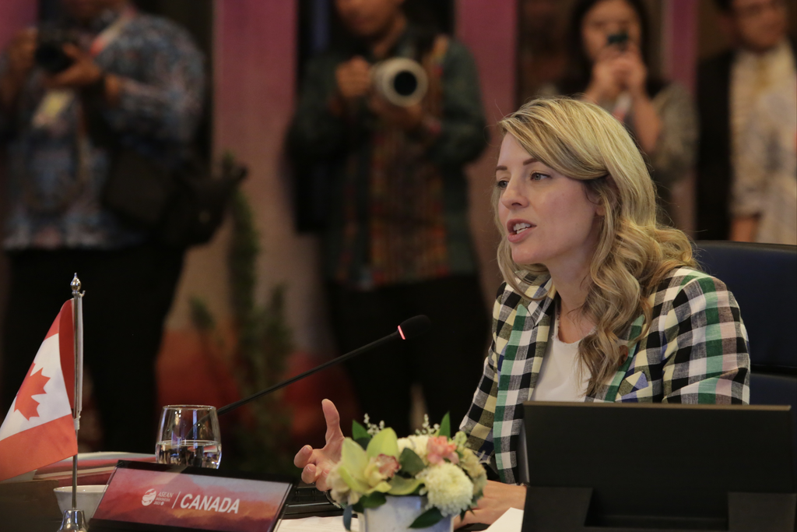

Indonesia has urged for ASEAN and Canada to strengthen cooperation in the field of food security during the ASEAN - Canada Post Ministerial Conference (PMC) meeting in Jakarta (13/7) (Photo: Ministry of Foreign Affairs of Indonesia).

